/******************************************************************************
***
* DPS912-Lab1
* I declare that this lab is my own work in accordance with Seneca Academic Policy.
* No part of this assignment has been copied manually or electronically from any other source
* (including web sites) or distributed to other students.
*
* Name: Mansoor Ahmad Zafar
* Student ID: 100503226
* Date: Tuesday, May 12, 2026
******************************************************************************
**/
D1) On a scale from 1 to 5, How much did you use generative AI to complete this
assignment?
▪ where:
▪ 1 means you did not use generative AI at all
▪ 2 means you used it very minimally
▪ 3 means you used it moderately
▪ 4 means you used it significantly
▪ 5 means you relied on it almost entirely
▪ Your answer : 2
o D2) On a scale from 1 to 5, How confident are you in your understanding of the
generative AI support you utilized in this assignment, and in your ability to explain it if
questioned?
▪ where:
▪ 1 means "Not confident at all – I do not understand the generative AI support I used and cannot explain it."
▪ 2 means "Slightly confident – I understand a little, but I have many uncertainties."
▪ 3 means "Moderately confident – I understand the majority of the support, though some parts are unclear."
▪ 4 means "Very confident – I understand most of the AI support well and can explain it with minor gaps."
▪ 5 means "Extremely confident – I fully understand the generative AI support I used and can clearly explain or justify it if asked."
▪ Your answer: 5

Questions & Screenshots
1) Main Program Output Screenshots
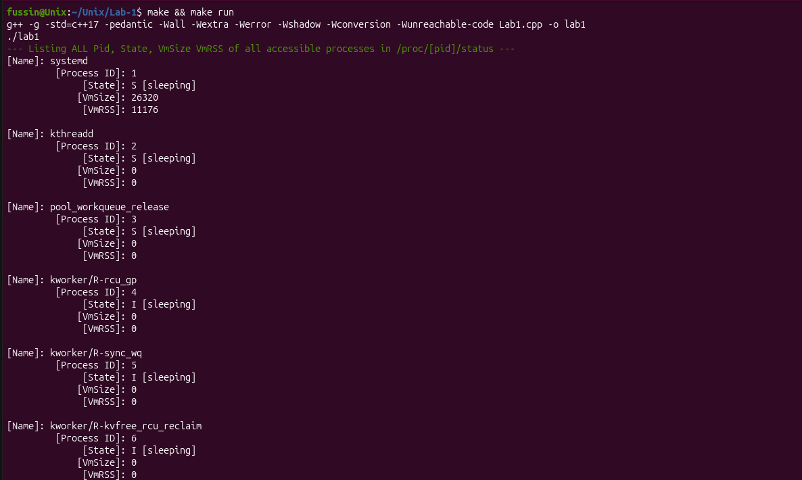
Truncated output in-between since it’s just a list of processes following the same kind of output
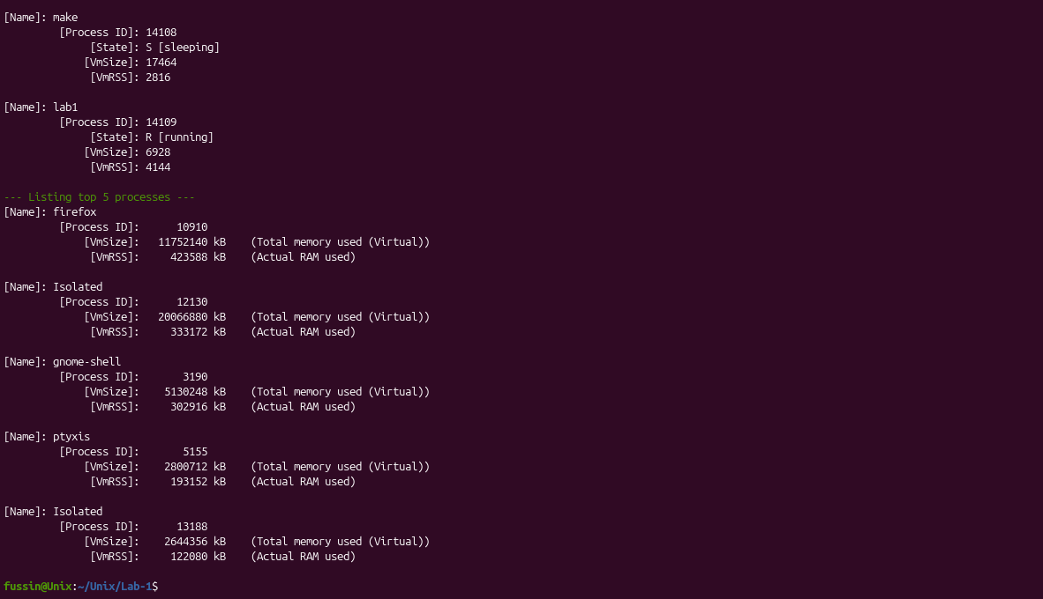
Matrix Result:
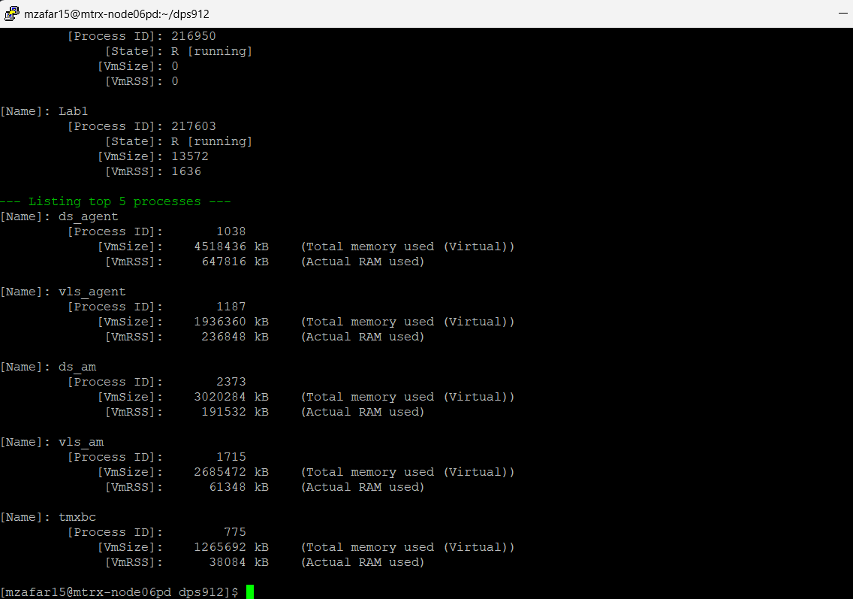
2)
The only process that also appeared in the top command was, gnome-shell, ptyxis, and firefox. The difference was mine had two processes called Isolated.
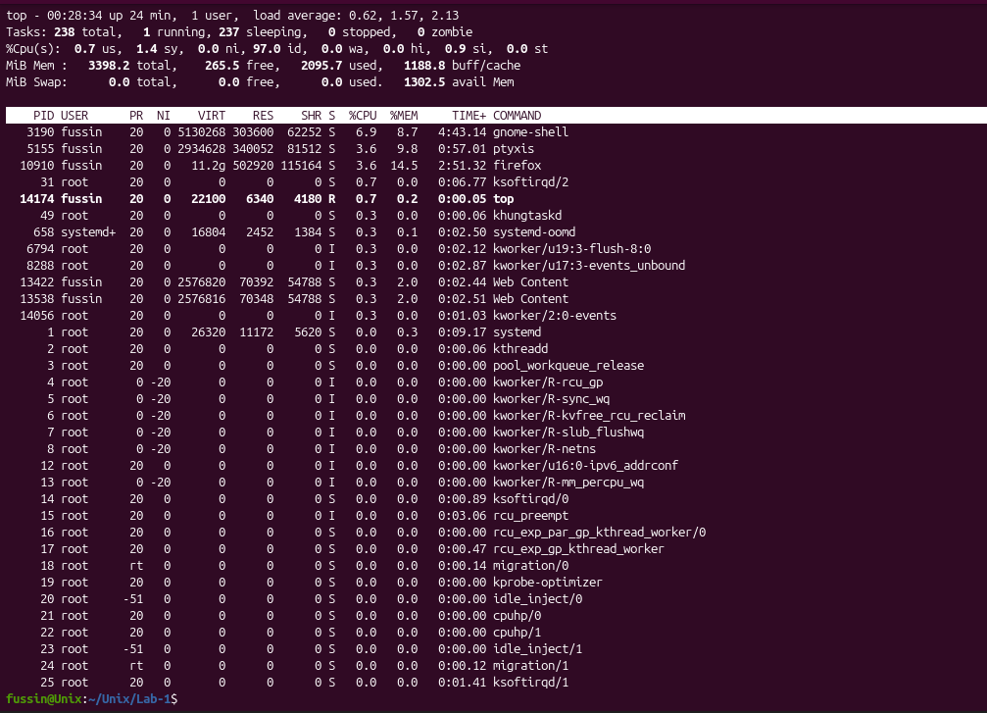
3)
Virtual Memory is a memory management technique used to create and manage the total memory a program has whereas residential memory is the actual memory a process is using that is loaded into RAM. So, virtual memory is a way for a process to interface with the memory as if it had all the memory available and residential memory is just how much memory is actually loaded into RAM.
4)
Local Machine:
gnome-shell:
This process is the process that manages the GUI for ubuntu. More specifically it is the GUI for the desktop part, so not the apps but rather the top bar, navigation bar, notifications, window management, overview etc.
ptyxis:
This process is just an isolated terminal emulator that is also the default one used. So it’s the process that manages and is the terminal that we use in Ubuntu.

Matrix Machine:
ds_agent:
This process is the main process for the security service, Trend Micro Deep Security Agent (DSA) that manages the other (DSA) processes like vls_agent, ds_am, etc. It manages the other security processes and acts as the main monitoring program.
tmxbc:
This process is an installation and management program where it manages updates, health and deployment of the other DSA programs. It is a part of the Trend Micro Deep Security Agent (DSA) programs.
systemd: ( as tmxbc is just another program managed by ds_agent, I did this one as-well )
This process just manages the system, background services and controlling system resources.

